NAME: DENNIS MURUKA
REGISTRATION NUMBER: BIT/2025/67727
COURSE TITLE: MOBILE APPLICATION DEVELOPMENT (BIT 4107)
ASSIGNMENT TASK: ENTITY RECORD MANAGEMENT APP (SQLITE VALIDATION)
Week4 to week 6

Document Structure Index
1. Cover Page & Index 1
2. Executive Summary & Architecture Design 2
3. User Authentication Flow Layout 2
4. Core Form Design & Create Operations 3
5. Database Read Operations & Dynamic View Management 4
6. Data Mutation Layout (Update & Delete Routine) 5
7. Logbook Entry Compilation Matrices 6

1. Executive Summary & Architecture Design
The project outlines the full implementation of a localized SQLite Database system integrated
seamlessly into an asynchronous mobile user interface architecture to deliver high-performance client-side
2. User Authentication & Entry Flow Layout
The report initializes by demonstrating app launch sequence metrics and localized state verification layouts
A. App Launch Screen Setup


B. Credential Access Forms
Detail secure entry control layout configurations, field control validations, and local session checking . 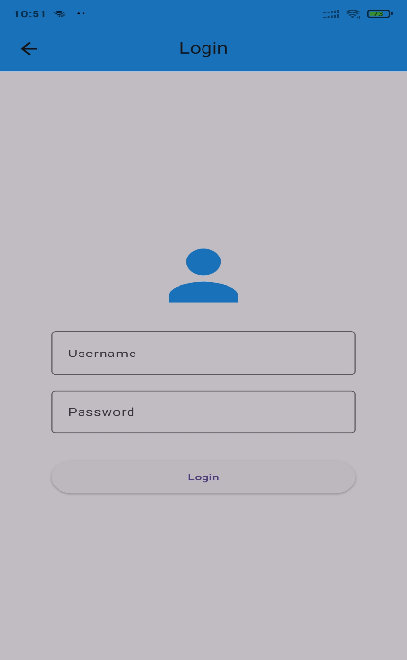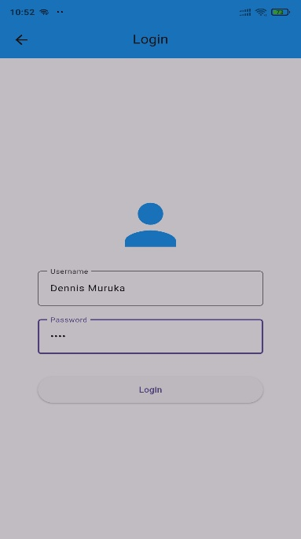

3. Core Form Design & Create Operations
This section delineates data collection handling methods, mapping client input fields directly to local relational
A. Interactive Main Control Deck
Describe the central navigation matrix

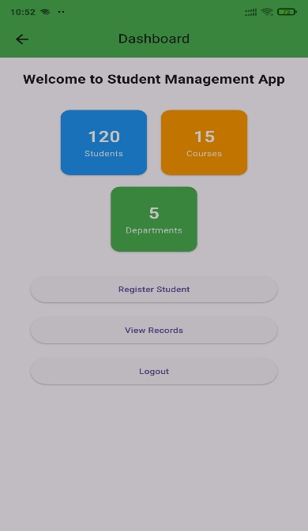

B. Unpopulated Input State Configurations
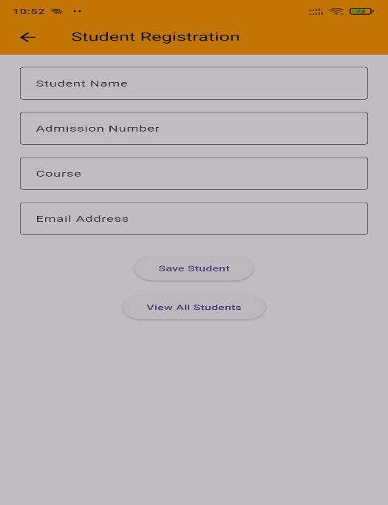
[Screenshot_04_RegistrationForm.png]
C. Populated Schema Validation
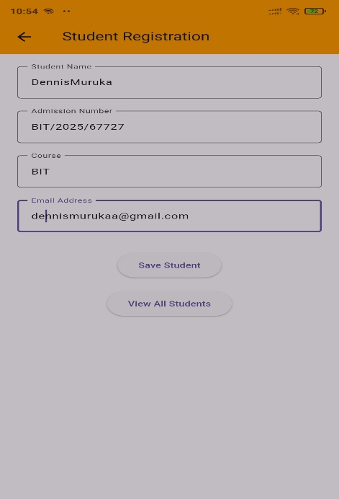
[Screenshot_05_RegistrationWithData.png]

D. System Interception Responses
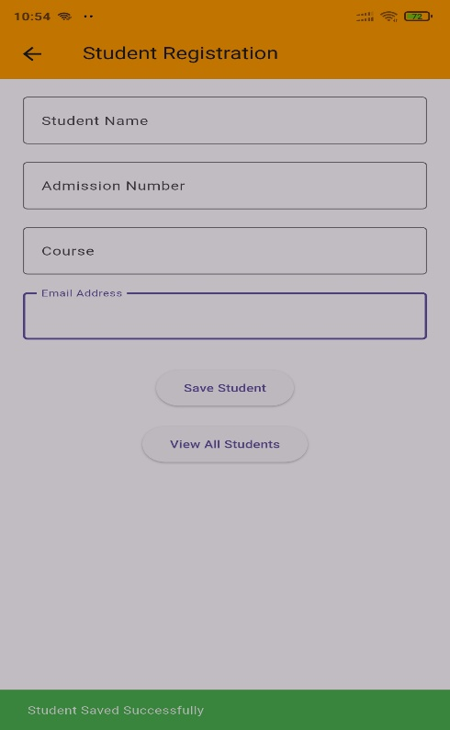
[Screenshot_06_CreateSuccess.png]

4. Database Read Operations & Dynamic View Management
Analyse record tracking execution routines, highlighting asynchronous retrieval workflows designed to query, relational databases safely without inducing user interface lag.
A. Empty State Interception Models
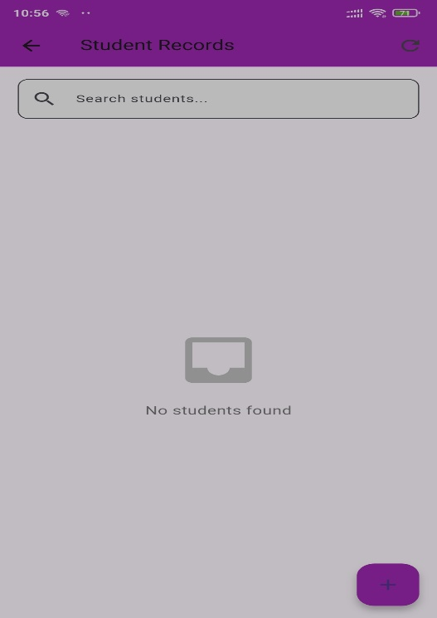
[Screenshot_07_EmptyList.png]

B. Dynamic Recycler Components (Dynamic Rows)
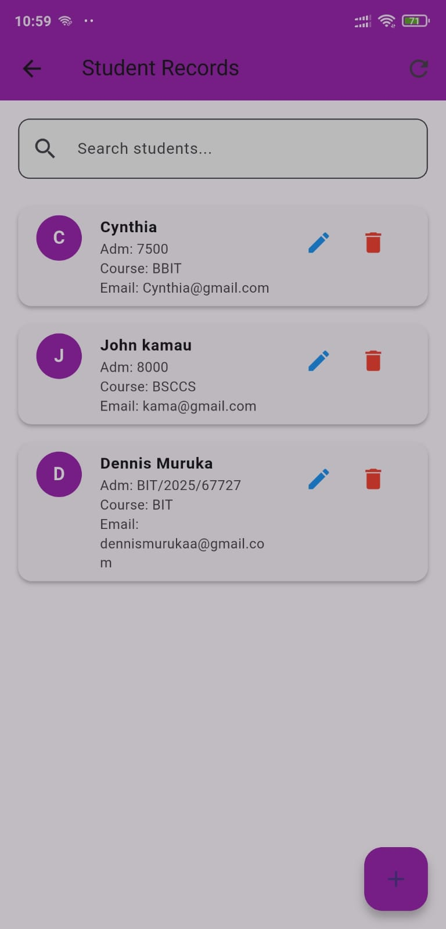
[Screenshot_08_StudentList.png]
C. Real-time Search Indexing Filters
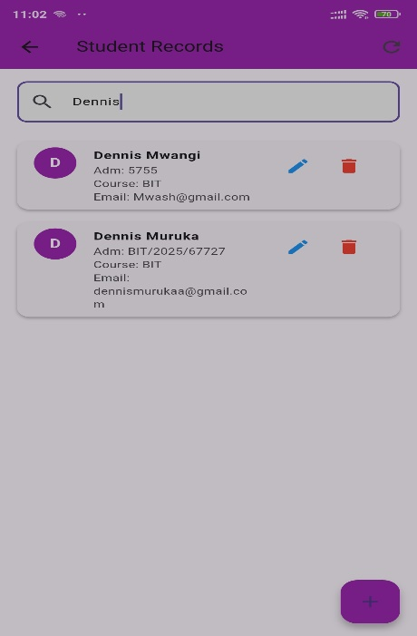
[Screenshot_09_SearchResults.png]

5. Data Mutation Layout (Update & Delete Routine)
Document parameters handling target data modifications, outlining exact procedural mechanisms that ensure, safe records alteration and transactional security.
A. Record Edit Pre-Population Layouts
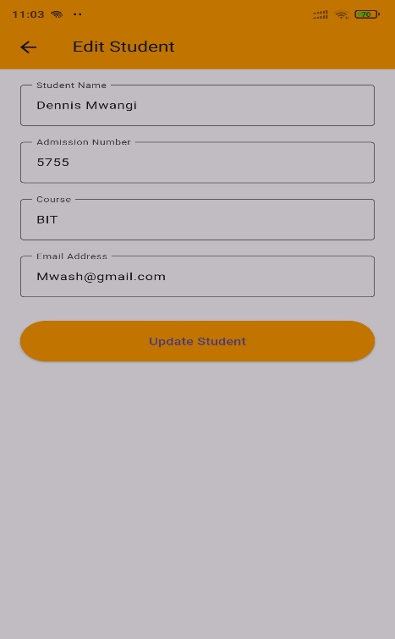
[Screenshot_10_EditPage.png]
B. Safe Modification States
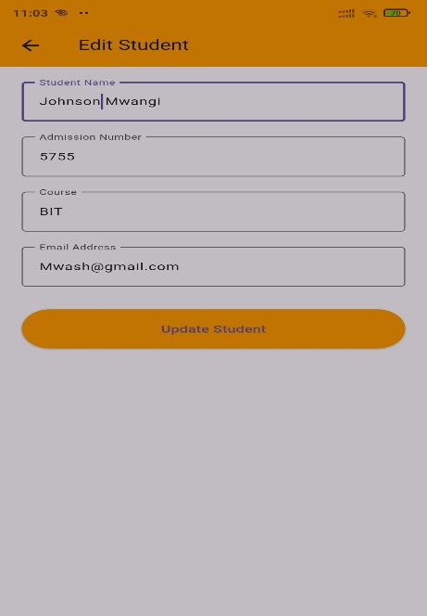
[Screenshot_11_EditModified.png]

C. Mutated Commitment Verifications
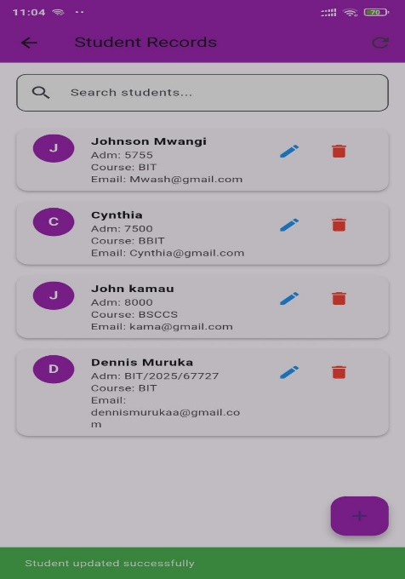
[Screenshot_12_UpdateSuccess.png]

D. Protective System Interception Dialogs
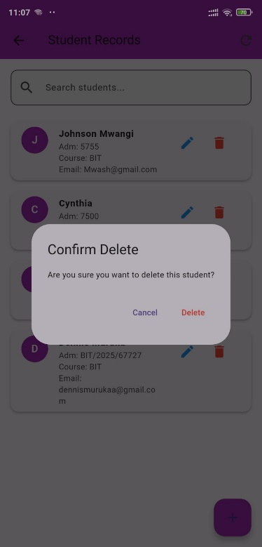
[Screenshot_13_DeleteDialog.png]

E. Removal Success Interceptions
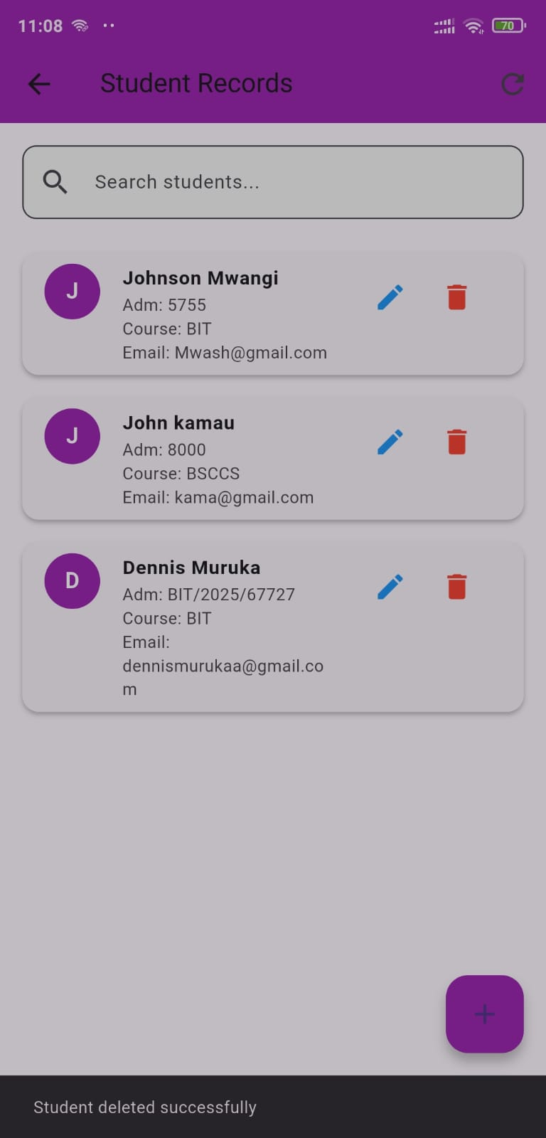
[Screenshot_14_DeleteSuccess.png]

